New RSQUARED^DQ^JRNL^TASK

Introduction | Currently, the DQ^JRNL^TASK handles each dequeue/journal message using a safestore address. See Figure 1 for a picture of the current queue manager/application messaging mechanism (all names have been changed to protect the innocent). However, with the advent of the rollover queue manager, a safestore address is no longer sufficient because it is reading and writing from several filesets. For example, if an application tells a queue manager to journal safestore address 512, how does the queue manager know from which file? Using improvisation and a little imagination, development was able to create what would happen in this scenario. See Figure 2 for more details. Be careful; the dialogue is not for the faint of heart.  All applications (DYNRBLD, DOTX, OLMAN and OARSUM) dequeuing from the new rollover queue manager must be able to handle a fileset as well as a safestore address. A new task called RSQUARED^DQ^JRNL^TASK will be developed to handle dequeue and journal messages with respect to a rollover queue manager.  This new task will be an enhancement of the current DQ^JRNL^TASK. In the interest of time, this portion of the document assumes a knowledge of the current DQ^JRNL^TASK. See Figure 3 for a picture of the new interface between each application and its R²QM.

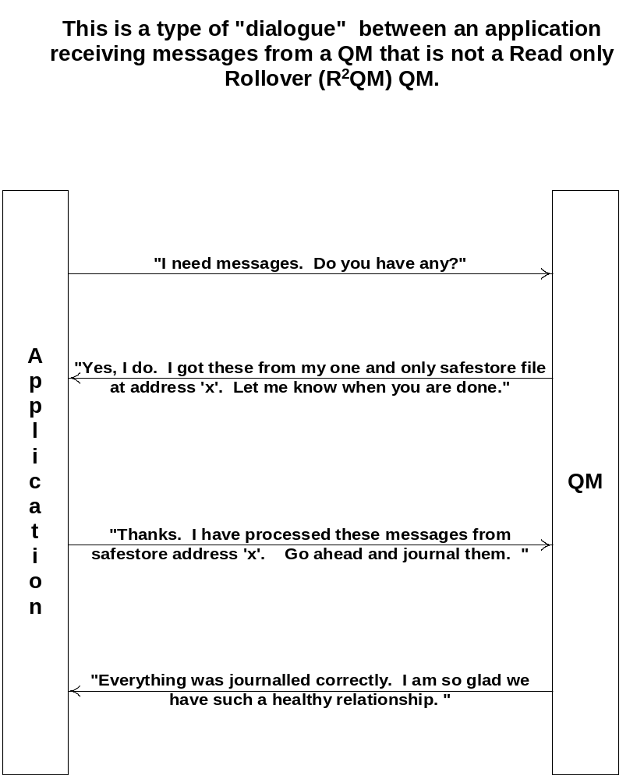
Figure 1

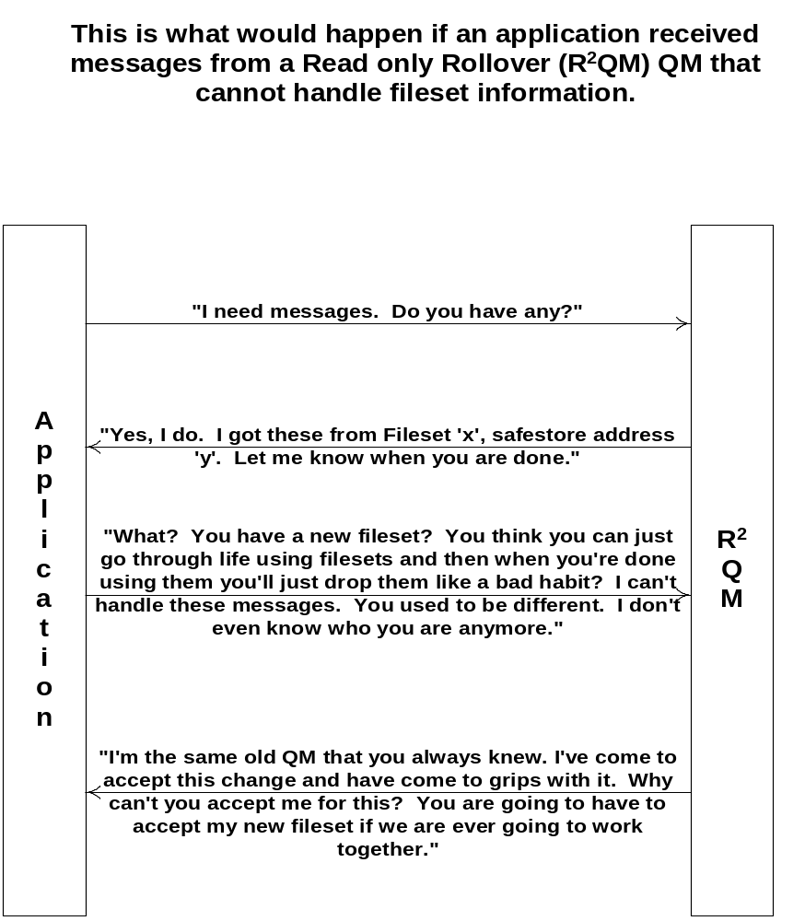

Figure 2

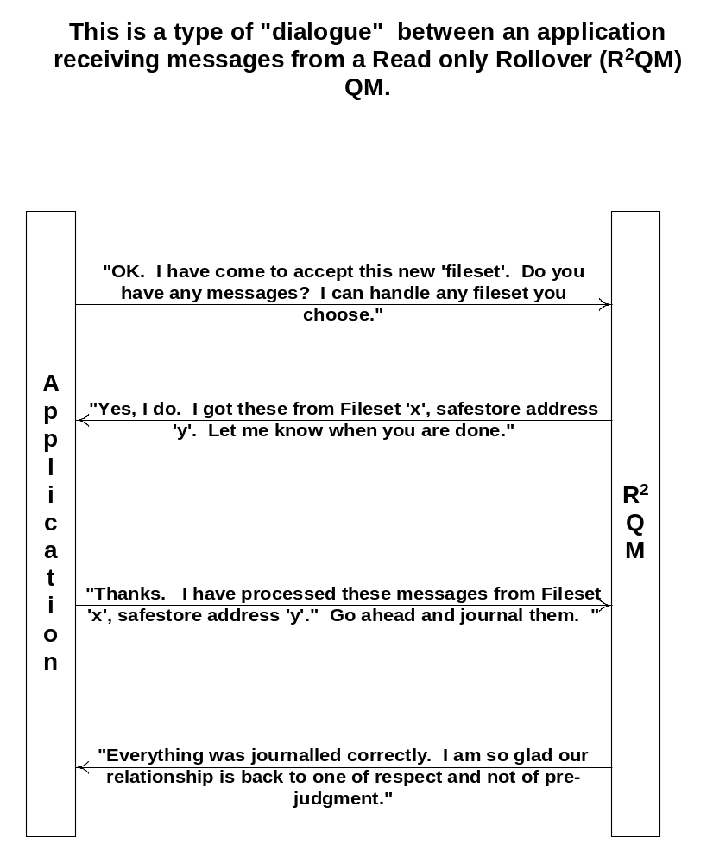

Figure 3

New RSQUARED^DQ^JRNL^TASK, Continued

RSQUARED DEQUEUE  JRNL  TASK | Now for Jerry Springer’s Final Thought:  Did anyone else sense some tension between the two processes in that last picture? Well, they both said some pretty hurtful things that cannot be taken back. So in the interest of peace, an open-minded mediary called “RSQUARED^DQ^JRNL^TASK” has been designed handle the messaging between the application and the R²QM.  It must do everything that the current dq/jrnl task does, in addition to handling the fileset information in the R²QM’s dequeue response and the journal request messages.  Fortunately, each application is mature enough to embrace the R²QM’s polygamy instead of fighting it. To whit: each application will be responsible for sending the fileset id on the journal request to the R²QM.

Startup | RSQUARED^DQ^JRNL^TASK is an extension of the current task responsible for dequeuing and journaling to a queue manager.  All applications that dequeue from XREF’s R²QM must start up and send messages to this task.  There are three startup parameters that will be sent to the task: a main task id where each message will be sent, an SDF process entity, and the queue-dequeue entity where the application will be dequeuing and journaling from. This is the same way that the non-rsquared task works.

Dequeue Requests | No changes to any of these messages. The dq/jrnl task will perform a normal CS^DEQ request message.
Continued on next page
New RSQUARED^DQ^JRNL^TASK, Continued

Dequeue Responses | The new response from the queue manager will have a fileset included in each message. When the dq/jrnl task receives a dequeue response type from the queue manager, the dq/jrnl task must send the fileset as well as the safestore address to the main task.  A response from a non R²QM looks like this:  MSG^DEF +  CS^DEQ^RESP^ITM^DEF +  Safestore address +  <Message to be processed by main task>  The response from the R²QM will be in the following format:  MSG^DEF +  CS^DEQ^RESP^ITM^DEF +  Fileset id +  Safestore Address +  <Message to be processed by main task>  This actually involves no code changes. The current dq/jrnl task sends whatever data exists at the end of the CS^DEQ^RESP^ITM^DEF to the main task.

Journal Requests | The main task must send a journal request to the new dq/jrnl task when it is done processing the message. It will send the request with both fileset and safestore address accompanied with the message.  Currently, the journal request is in the following format:  MSG^DEF +  CS^JRNL^REQ^BUFFER^DEF

Continued on next page
New RSQUARED^DQ^JRNL^TASK, Continued

Journal Requests (continued) | The request from the main task will be in the following format:  MSG^DEF +  CS^JRNL^REQ^BUFFER^MFS^DEF  The only code change needed is to handle the new CS^JRNL^REQ^BUFFER^MFS^DEF structure when it is received from the main task.

Journal Responses | The journal response from the R²QM remains the same and requires no code changes.

Warm Start | The dq/jrnl task is also responsible for pushing messages that were in transit back onto the message queue. Currently, this is done by using the Common Software function CS^PUSH^IN^TRANSIT. There is an optional first parameter that must be used for the applications using a R²QM.  Change the CS^PUSH^IN^TRANSIT call to support R2QM dequeues by sending the “queue-dequeue” entity sent in the startup message as the first parameter to CS^PUSH^IN^TRANSIT.

